[Enter Forest Management Plan Title Here]

Owner’s Name(s):

Plan Time Period: Click or tap here to enter time period.

Plan Author: Click or tap here to enter your name.

Plan Author’s Contact Information: Click or tap here to enter your contact info.

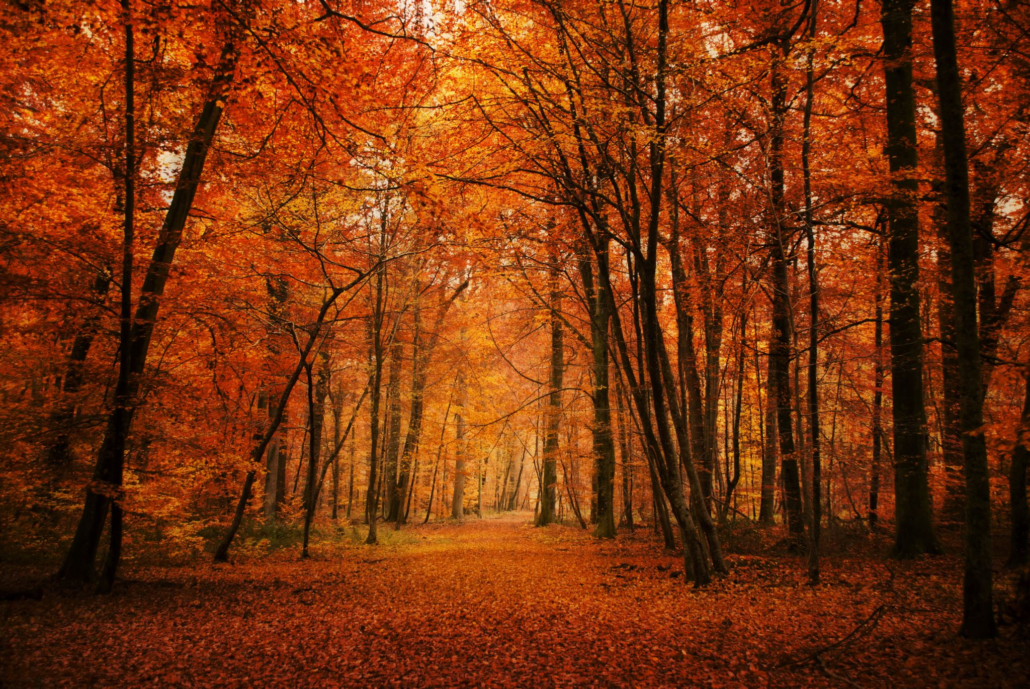

Contents

Contents 2

Introduction 3

Property Ownership 3

Property Description 4

Land Use History 5

Tax and Business Management 5

Forest Management Objectives 6

Property Map(s) 7

Property Overview 8

Special Sites and Social Considerations 8

Water and Soil Protection 8

Fish, Wildlife, and Biodiversity 9

Management of Forest Resources 10

Professional Assistance 13

Stand-Level Information 14

Stand Description 14

Forest Management Activities 15

Signatures and Approvals 17

Introduction

Property Ownership

**Landowner:** Click here to enter landowner name(s).

**Mailing Address:** Click here to enter mailing address.

**Phone:** Click here to enter the landowner’s phone number.

**E-mail:** Click here to enter the landowner’s email address.

**Date of Plan Completion:** Use the dropdown arrow to select the date.

Property Description

**Legal Property Description:**

Click here to enter legal property description.

**Nearest City or Town:** Click here to enter nearest city.

**County:** Click here to enter county.

**Coordinates (Decimal Degrees):** xxx, yyy.

**Total Ownership Acreage:** Click here to enter acreage.

**Total Forested Acreage:** Click here to enter acreage.

**Total Acreage Covered by this Plan**: Click here to enter acreage.

**Number of unique stands of trees, or management units:** Click here to enter.

**Does the Landowner Reside on the Property?** Yes or No?

**Description of Basic Topography** (see Appendix B for information on common topographical descriptions in bottomlands)**:** Click here to enter description of basic topography.

**Forest Access to Vehicles (choose one):**

Inaccessible (can’t access forestland with a vehicle)

Poor (less than 50% accessible)

Good (50 to 75% accessible)

Great (more than 75% accessible)

**Watershed**: Click here to enter watershed data.

Land Use History

**Historical Landscape Context:** Identify and describe cultural or historic resources, land use rights and Indigenous rights (if applicable). It is important to acknowledge the history of the landscape as a whole, including the presence of Indigenous peoples and their connection to the land. As the original stewards of this land, they shaped the forest’s unique mix of tree and other plant species, soils and waterways, and habitat for wildlife. For more information and to see an example, please see Appendix H.

Click here to enter the historical landscape context of your property (narrative). Include any Indigenous connections and other social histories.

**Management History:**

Click here to enter the management history of the property (narrative).

Tax and Business Management

**Real Estate Information:**

Click here to enter tax map numbers.

**Property Tax Information:**

Click here to enter property tax information. What are the property parcels currently being taxed as (e.g. forest, farm, etc.)?

Forest Management Objectives

The principal management objectives for the ownership.

**Objective 1:** Click here to describe the landowner’s first management objective (narrative).

**Objective 2:** Click here to describe the landowner’s second management objective (narrative).

**Objective 3:** Click here to describe the landowner’s third management objective (narrative).

**Objective** Enter Number**:** Click here to describe the landowner’s next management objective (narrative) and click the ‘+’ to add more list items.

Property Map(s)



Property Overview

Special Sites and Social Considerations

**Protect Special Sites and/or High Conservation Value Forests:** Can include sites such as permanent structures, historic resources sites, culturally significant sites (e.g. old stone walls from past land uses), etc. These sites should be buffered out of any management activity on the property, if desired by the landowner. If applying for certification with FSC, [further documentation](https://www.nnrg.org/wp-content/uploads/2019/03/Guidance-for-FSC-Forest-Management-Plan.pdf) of identified HCVFs may be necessary.

Click here to enter text (narrative).

**Adjacent Land or Ownership Considerations:** Bottomland hardwood forests of the ACP have been severely fragmented and only small sections of the original millions of acres exist. Due to this, it is important to understand the function, condition and needs of these forests on the landscape-level, particularly when managing for wildlife.

Click here to enter text (narrative).

**Recreation:** Are there recreational values associated with the property (e.g. hunting, hiking)?

Click here to enter text (narrative).

**Access:** How to access the property.

Click here to enter directions (narrative).

Water and Soil Protection

Awareness of site limitations such as soil capabilities and hydrologic conditions is important in deciding which silvicultural practices to implement. Any silvicultural and/or forest management operations should be done with consideration and adherence with your state’s Best Management Practices (BMPs). For recommendations on water quality and soil protection, road construction, and more operations specific to your state, a list of places to find Atlantic Coastal Plain states BMP documents can be found in Appendix A.

**Water Protection**

In bottomland hardwood systems, it is essential to minimize disturbance to hydrological features. Additionally, if applying for FSC certification there is a set of [minimum riparian buffer standards](https://www.nnrg.org/wp-content/uploads/2019/04/Guidance-for-FSC-Management-of-Riparian-Buffers.pdf) to be followed. List efforts that will be made to reduce impacts to water quality (often can be copied from your state’s BMP manual):

* Example: Plan streamside management zones (SMZs) before the beginning of the timber harvest and mark SMZ boundaries prior to harvest where they can be clearly seen.
* Click here to enter text.
* Click here to enter text.
* Click here to enter text and click the ‘+’ to add more list items.

**Annual Monitoring of Road and Culvert Systems**

If applying for FSC forest certification, land managers must have a forest road system monitoring program in place to assess the condition and environmental impacts. Monitoring includes: observing and maintaining bridges and culverts for functional drainage, maintaining roads for large cracks, sink holes, and other damages; observing uphill side of roeads for eorisoin into ditch systems; observing downhill side of roads for erosion into streams, ponds, or wetlands; observing water flow; evaluating orphaned roads, culverts, bridges, and road conditions.

**Soil and Erosion Protection**

As with protecting a site’s natural hydrology, it is important to minimize disturbance to soils. List efforts that will be made to reduce impacts to soils (often can be copied from your state’s BMP manual):

* Example: Build roads on higher ground and with the site’s natural contour.

* Click here to enter text.
* Click here to enter text.
* Click here to enter text and click the ‘+’ to add more list items.

Fish, Wildlife, and Biodiversity

**Fish and Wildlife:** Bottomland hardwood ecosystem management activities on the property will increase the habitat for desired wildlife species (game, songbirds, etc). Identify and describe significant fish and wildlife that utilize the site, the habitat quality for these species and any management activities to improve habitat conditions. For additional guidance on landscape-scale wildlife habitat needs, please refer to Appendix C.

List the desired wildlife improvement activities, as applicable:

* Example 1: Increased recreational wildlife viewing opportunities because of improved habitat conditions.
* Example 2: Increased hard mast because of increased oak recruitment and maturation.
* Click here to enter text.
* Click here to enter text.
* Click here to enter text and click the ‘+’ to add more list items.

**State and Federal Threatened or Endangered Species- Plants or Animals:** A list of species of conservation concern by county and watershed can be found using your state’s [Natural Heritage Program](https://schtportal.dnr.sc.gov/portal/apps/sites/#/natural-heritage-program) or [DNR](https://georgiawildlife.com/conservation/species-of-concern) datasets. Find the at-risk species for the county and/or watershed of your management area and copy the table here.

Click here to paste dataset.

**Ecological Systems:** It is important to make note of the ecological communities primarily found on the property, as there might be several within a single stand. While there are many ways to classify the types of systems found in bottomland hardwood forests, a description of dominant forest types and steps to identify them can be found in Appendix B. Please refer to this Appendix to determine the primary ecological communities on the property.

Click here to enter forest site type information (narrative). Refer to Appendix B for guidance.

Management of Forest Resources

**Habitat Management Recommendations:** Three key steps in planning the management of bottomland hardwood forests include: (1) understanding current forest, hydrological, and environmental conditions; (2) clarifying landowner and landscape objectives (desired forest conditions); and (3) deﬁning economically and operationally feasible actions that will move the stand into the desired condition (Allen et al. 2004).To manage for wildlife in the bottomland hardwood forests of the ACP, there are general guidelines to follow to reach the desired landscape conditions (North Carolina Wildlife Resources Commission 2015; N.C. Wildlife Resources Commission 2012; Brunswig et al. 2016). Additional habitat management recommendations and desired forest conditions can be found in Appendix C.

General Recommendations for Wildlife Habitat Management**:** Check off recommendations as they are incorporated and/or followed in this plan.

Maintain large blocks of contiguous forested habitat.

Keep continuous buffers along perennial streams a minimum of 300 feet wide.

Retain no less than 5 percent of stands in the late-successional phase of stand dynamics, where possible[1].

Avoid unnecessary alterations of hydrology, but also work to restore natural hydrology

Limit management activities during bird breeding seasons (late March through July) when possible and avoid colonial waterbird nesting colonies entirely.

If compatible with regeneration objectives, retain overstory trees of varying types and sizes when harvesting. Keep trees that produce fruits, seeds, or nuts promoting widespread seasonality of mast production by favoring a diversity of tree species (e.g. black cherry, oaks, hollies, hackberries).

Leave trees and snags that have cavities of varying sizes and various locations on the trunk. When possible, preserve existing snags to provide two or more >21-inch dbh snags or six or more >10 inch dbh snags per acre of forest.

Soften edges between habitats. Reduce negative edge effects by creating irregular edges or by feathering edges. An “edge” can be defined as a place where two differing types of vegetation meet, e.g. deciduous forest meets grassland. Sharp edges, or an abrupt change between habitats, often have negative impacts on songbirds; these impacts are known as “edge effects.” Negative edge effects are greatest within about 150 feet of the forest edge.

Minimize linear openings (e.g. truck/skidder roads, ATV trails). Whenever possible, maintain forest canopy closure over trails and woods roads.

Retain appropriate levels of early successional forest habitat. Take care to limit patch acreages to <10 acres and comprising no more than 10% of a stand, as applicable.

Limit management that would increase the extent of invasive species in areas with >10% of the total plant cover consisting of exotic species where plant cover can be measured via basal area, canopy cover, stem count, etc.

**Forest Health Concerns:** Invasive exotic pests, pathogens, and plants pose a major threat to the health of bottomland hardwood forests, negatively affecting species composition and natural regeneration. Foresters and landowners need to plan for the effects from invasives to achieve long-term desired forest conditions. Always seek to address invasives before a silvicultural treatment, or in conjunction with the management activity.

For example, in many areas emerald ash borer (EAB), an invasive pest from Asia, poses a serious threat to ash trees (*Fraxinus* spp.), which can be an important commercial tree and critical to making many wildlife forestry treatments financially feasible. The loss of ash from the forest may reduce the ability for many managers to implement certain silvicultural treatments, at least with current market conditions. Therefore, having a strategy in place that understands how forest composition will change as EAB moves through the forest is vital. However, for some landowners with wildlife goals in mind, the wildlife benefits of retaining dead ash trees may outweigh the economic losses.

Complete the following table for any invasive exotic pests, pathogens, and plants that currently pose a threat to forest health or are likely to do so in the near future.

|  |  |  |  |  |
| --- | --- | --- | --- | --- |
| **Threat** | **Scope (%)** | **Severity**  **(1-10 scale)** | **Potential Impacts** | **Mitigation Strategy** |
| Example: EAB | 20% of property | 4 | Mortality to mature ash trees | Harvest log-sized ash where possible while markets are available |
| Example:  Tallow tree | 10% of property | 9 | Loss of native vegetation and degradation of habitat | Use mechanical and wetland-safe chemical eradication methods |
| Click here to enter threat. | Click here to enter scope. | Choose from the list. | Click here to enter text. | Click here to enter strategy. |

**Reforestation and Afforestation:** Bottomland hardwood forests are often considered wetlands. A crucial best management practice is to ensure that activities do not convert wetlands to non-wetland (immediately or gradually). Briefly describe any activities that will be conducted to establish desired tree species, in both the short and the long term.

Click here to enter text (narrative).

**Economic and Operational Constraints:** Identification of alignment between a landowner’s goals and the needs and limitations of the landscape are imperative to implementing effective wildlife forest management. Implementing wildlife forestry practices in bottomland hardwood forests may not be financially feasible for every landowner, as less timber revenue is generated with each harvest entry compared to conventional practices. If NRCS has applicable cost-share funding available, this could greatly help offset the costs of wildlife forestry activities and incentivize desired forest management outcomes.

Check each box as each is taken into consideration:

The implementation of recommended management activities in this plan is at the discretion of the landowner.

Alignment between landowner’s goals and the needs of the landscape.

Awareness of landscape limitations that may affect operations.

NRCS cost-share - compliant activities are outlined in this plan.

Other economic constraints have been taken into consideration (Appendix G)

Other operational constraints have been taken into consideration (Appendix F)

Additional information to address economic and operational constraints can be found in Appendix F and Appendix G.

**Monitoring of Forest Resources:** Describe the basic plan for monitoring forest growth and dynamics, wildlife habitat and impacts of management activities. Depending on the size and scale of your forest management, effective monitoring can take a variety of forms.

* Example: Go on a forest walk twice per year and take notes about observations of forest health issues, wildlife sightings, natural disturbances, conditions of roads, etc.
* Click here to enter text.
* Click here to enter text.
* Click here to enter text and click the ‘+’ to add more list items.

Professional Assistance

**Assistance:** The landowner has consulted Click here to enter your organization. and partners regarding special sites and threatened species concerns. The plan has also been reviewed by Click here to enter additional names or organizations..

# 

# **Stand-Level Information**

Stand Enter stand number. Description

|  |  |
| --- | --- |
| **Stand Forest Type:** Click here to enter forest type.  **Acres:** Click here to enter acres.  **Overstory Average DBH:** Click here to enter DBH.  **Overstory Basal Area:** Click here to enter BA.  **Overstory Density:** Click here to enter density.  **Midstory Species:** Click here to enter common species.  **Groundcover Species:** Click here to enter common species.  **Percent Groundcover:** Click here to enter groundcover.  **Site Index:** Click here to enter site index.  **Dominant Soil Series:** Click here to enter dominant soil series. |  |

**Objectives:**

Click here to enter objectives for this stand (narrative).

**Current Description:** In this section, describe the history of the stand, current phase of stand dynamics, approximate age(s) of the stand, hydrologic conditions, aspect and slope, inventory data for commercially harvested products, stocking levels, and any other information relevant to management.

Click here to enter current stand description (narrative).

**Stand Management Recommendations:**  Describe the desired future conditions of the stand and the silvicultural system that will be used to achieve those conditions.Please refer to Appendices C and D for guidance on general silvicultural treatments for bottomland forests. Additionally, determine the sustained yield harvest level (in mbf/yr) such that harvest levels and rates do not exceed growth over successive harvests (annual allowable cut).

Click here to enter stand management recommendations (narrative).

Forest Management Activities

Summarize management activities and include associated costs in the table below and add rows as needed. The landowner should engage their local NRCS field office about the eligibility of different management activities outlined in this plan for cost-share funding.

**Management Activity Schedule and Tracking for Next Ten Years**

|  |  |  |  |  |  |  |  |  |
| --- | --- | --- | --- | --- | --- | --- | --- | --- |
| **Stand** | **Activity** | **Units** (acres, feet, etc) | **Incentive Program(s) Used?** | **Code** | **Dates** | **Implementation** | **Rate** | **Cost**  **(Unit x Rate)** |
| Ex:  1 | Creating Patch Clear-cuts | 14 ac | NA | NA | 2020-2021 | Contractor | $377.16 | $ 5,280.24 |
| Stand number | Enter activity | Enter units | Enter program | Activity code | Dates | Who will do the activity? | $Enter rate | $Enter cost |
| Stand number | Enter activity | Enter units | Enter program | Activity code | Dates | Who will do the activity? | $Enter rate | $Enter cost |
| Stand number | Enter activity | Enter units | Enter program | Activity code | Dates | Who will do the activity? | $Enter rate | $Enter cost |
| Stand number | Enter activity | Enter units | Enter program | Activity code | Dates | Who will do the activity? | $Enter rate | $Enter cost |
| **Total** | | | | | | | | **$** Enter total |

**\***NRCS Practice Code needed if practice will be submitted for an NRCS incentive program, otherwise leave blank.

**Long-Term Management Activity Schedule and Tracking for Year 11 and Beyond**

|  |  |  |  |
| --- | --- | --- | --- |
| **Stand** | **Activity** | **Implementation** | **Year** |
| Ex: 7 | Prescribed burning | Certified Burn Manager | 2031 |
| Enter stand number. | Enter description of activity. | Who will implement the activity? | Enter dates. |
| Enter stand number. | Enter description of activity. | Who will implement the activity? | Enter dates. |
| Enter stand number. | Enter description of activity. | Who will implement the activity? | Enter dates. |
| Enter stand number. | Enter description of activity. | Who will implement the activity? | Enter dates. |

Signatures and Approvals

**Landowner**

I have reviewed this plan and believe the management recommendations will help me meet my goals and objectives for my property. I agree to follow this plan to ensure the sustainability of my management.

________________________________________________________ ___________________

Landowner Date

**Forester**

I have written/reviewed this plan and believe the management recommendations will help meet the landowner’s goals and objectives. I certify that the information provided is completed to the best of my ability and knowledge.

_______________________________ ____________________ ___________________

Forester Number Date

**NRCS Incentive Programs**

I certify that this Forest Management Plan meets the requirements of the USDA Environmental Quality Incentives (EQIP) Program and/or the Quality Criteria for forest activity plans in Section III of the USDA NRCS Field Office Technical Guide.

________________________________________________________ ___________________

Plan Author Date

________________________________________________________ ___________________

Technical Service Provider (Optional) Date

1. Late successional bottomland hardwood forests are at least 80 years old and have complex heterogeneous characteristics, including high structural diversity, high species diversity, high age-class diversity, and diverse diameter distributions, but are not necessarily in the old growth phase of stand dynamics.